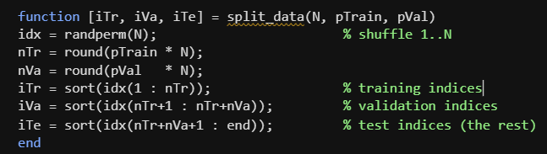
Random splitting of the data into testing, training and validation sets for the ANN

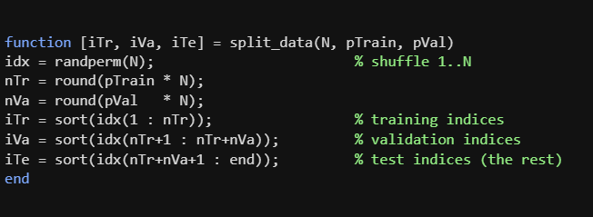
Improved visualization for the data
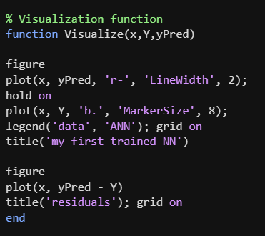
Testing and validation integration
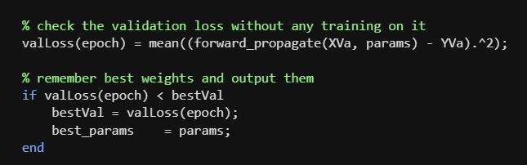
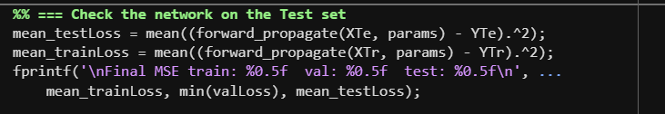
Output of the ANN contains two structs named [results and losses], containing
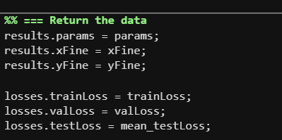

Swappable activation functions
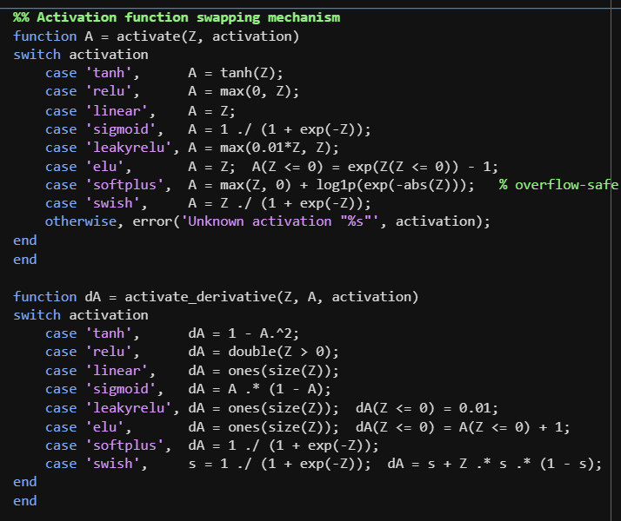
Standardising the input values
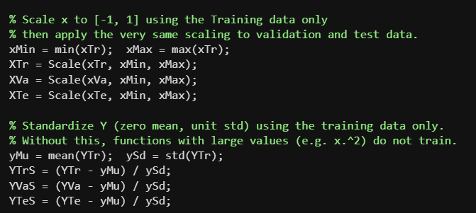
Modified Forward and back prop functions for any number of layers
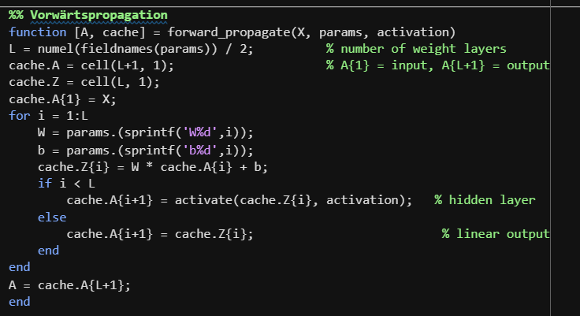

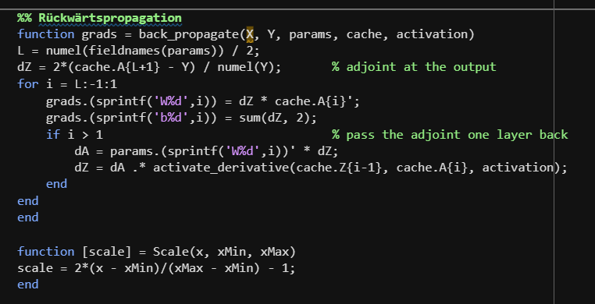
Comparison metrics
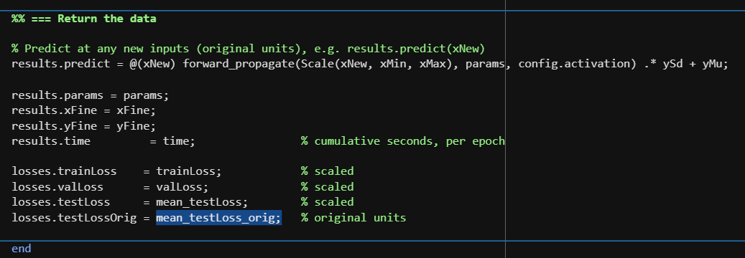
Scaled test MSE
Time to target
Time per epoch
Testing error
Gap between test and training error
Number of parameters [input, hidden, output] (model complexity)

Single step versions for ANN
A complete ANN function
Test rig

